SMART DIABETES AND REPORTING SYSTEM

Code:
!pip install reportlab

import gradio as gr
import pandas as pd
import numpy as np
from sklearn.linear_model import LogisticRegression
from reportlab.pdfgen import canvas
import smtplib
from email.message import EmailMessage
from google.colab import userdata

# Load dataset and train model
dia = pd.read_excel("/content/diabetes.xlsx")
model = LogisticRegression()
X = dia[['mass', 'insu', 'age', 'plas']]
y = dia['class']
model.fit(X, y)

# Function to predict, generate PDF, and send email
def predict_and_send_report(name, blood_group, email, mass, insu, age, plas):
# Predict
input_data = np.array([[mass, insu, age, plas]])
prediction = model.predict(input_data)[0]
result = "✅Diabetic" if prediction == 1 else "❌Not Diabetic"

# Create PDF report
pdf_filename = f"{name.replace(' ', '_')}_diabetes_report.pdf"
c = canvas.Canvas(pdf_filename)
c.drawString(100, 800, "Diabetes Prediction Report")
c.drawString(100, 780, f"Name: {name}")
c.drawString(100, 760, f"Blood Group: {blood_group}")

c.drawString(100, 740, f"Email: {email}")
c.drawString(100, 720, f"Mass (BMI): {mass}")
c.drawString(100, 700, f"Insulin: {insu}")
c.drawString(100, 680, f"Age: {age}")
c.drawString(100, 660, f"Plasma Glucose: {plas}")
c.drawString(100, 640, f"Prediction Result: {result}")
c.save()

# Send email
msg = EmailMessage()
msg['Subject'] = "Your Diabetes Prediction Report"
msg['From'] = "dharshiniganeshan10@gmail.com"
msg['To'] = email
msg.set_content("Dear Patient,\n\nPlease find attached your diabetes prediction report.\n\nRegards,\nHealth AI")

with open(pdf_filename, 'rb') as f:
file_data = f.read()
msg.add_attachment(file_data, maintype='application', subtype='pdf', filename=pdf_filename)

try:
with smtplib.SMTP_SSL('smtp.gmail.com', 465) as smtp:
smtp.login("23ucs104@gmail.com", "4e27ebd55dda686113e97051c74242db")
smtp.send_message(msg)
except smtplib.SMTPAuthenticationError:
return "Error: Authentication failed. Please check your email address and password (app password if using Gmail) and ensure that less secure app access is enabled or you are using an app password."
except Exception as e:
return f"An error occurred while sending the email: {e}"

return f"{result}. Report sent to {email}."

# Gradio UI
interface = gr.Interface(
fn=predict_and_send_report,
inputs=[
gr.Textbox(label="👤Patient Name", type="text", placeholder="Enter patient full name"),
gr.Dropdown(label="🩸Blood Group", choices=["A+", "A-", "B+", "B-", "O+", "O-", "AB+", "AB-"], value="O+"),
gr.Textbox(label="📧Email", type="email", placeholder="example@gmail.com"),
gr.Number(label="💪BMI (mass)"),
gr.Number(label="🧬Insulin Level"),
gr.Number(label="🎂Age"),
gr.Number(label="🩺Plasma Glucose")
],
outputs="text",
title="🔍Smart Diabetes Prediction and Reporting System",
description="Enter patient details to get diabetes prediction and receive a report via email."
)

interface.launch()

Output:
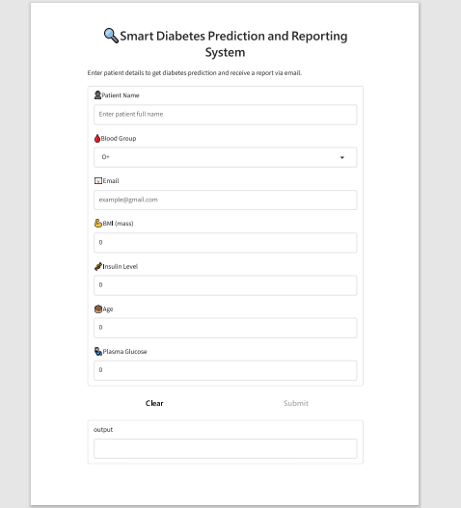

Sample report:
